

EMAIL
TEMPLATES
Promotional Copy to Help You
Promote Tutor.com to Your Patrons

Questions? Comments?
clientsupport@tutor.com
2020_LIB_Email_Templates

Promotional Topics Included in This Packet:

- Email Announcement to Library Staff
- Email Reminder to Library Staff
- Letter or Email to Schools
- Where to Find More Promo Materials
EMAIL ANNOUNCEMENT TO LIBRARY STAFF

Subject: Now Offering Online Tutoring and Career Help from Tutor.com!

Dear Colleagues,
On [INSERT DATE], [we will begin] / [we began] offering our patrons online tutoring and career help from Tutor.com! This new service will help us provide more in-depth homework help and career assistance to our youth, teen, and adult patrons.
What is Tutor.com? Tutor.com provides high-quality online learning and career services to libraries nationwide. We'll be offering the Tutor.com Learning Suite to give patrons access to live, online tutoring and resume help as well as thousands of academic and career resources.
Who can use the Tutor.com Learning Suite? Everyone! K-12 and college students can get help with homework, studying, projects, essay writing and test prep in every subject, including algebra, statistics, chemistry, physics, social studies and English. Adults can get help with job searches, academic support and test prep practice for the GED and HiSET exams, the ASVAB military entrance exam, and the following grad school tests: GRE, GMAT, LSAT, MCAT.
How does the online tutoring work? All sessions are online with professional academic or career tutors. Patrons can work with an online tutor [INSERT days and times of your program] by simply going to [INSERT your library’s unique program URL/access instructions].
Is the service available remotely? Yes. Patrons can connect to Tutor.com from any computer or mobile device with Internet access using their library card number.
Beyond our initial launch—and to ensure our Tutor.com program is a success—we need all staff to actively participate in promoting the program. Staff training and demo resources are available through the Tutor.com Partner Resource Center (PRC) at www.tutor.com/prc/libraries. All staff members are encouraged to attend a training session, view the videos and use the practice classroom. Please familiarize yourself with the program and be sure to share this great new resource with everyone!
If you have any questions about the launch or ongoing plans to promote this new service, please contact [INSERT your Tutor.com Client Service Manager’s name and contact info].

REMINDER EMAIL TO LIBRARY STAFF

Subject: Online Tutoring and Career Help from Tutor.com!
Dear Colleagues,
As we begin a new school year [OR INSERT APPROPRIATE SEASON/REASON FOR REMINDER], I wanted to remind you of one of our popular services for students and job seekers: Tutor.com!
The Tutor.com Learning Suite through our library offers online academic tutoring to K-12 and college students, as well as practice tests for adults taking the GED, HiSET, ASVAB, GRE, GMAT, LSAT, or MCAT exams, and provides career coaching to adult job seekers.
All sessions are conducted online by highly vetted expert tutors. Patrons can work with an online tutor [INSERT days and times of your program] by simply going to [INSERT your library’s unique program URL/access instructions]..
In addition to on-demand, online tutoring, the Tutor.com Resource Library is available 24/7. Patrons can search by keyword and subject for educational and career resources at [INSERT your library’s unique program URL/access instructions]..
Patrons can connect to the Tutor.com Learning Suite from any computer
with Internet access or any mobile device using their library card number.
Tutor.com helps us provide more in-depth homework help and career assistance to students and adults. Please remember to actively promote this service to our patrons so they are aware of the valuable ways our library supports them in their day-to-day lives.
If you would like to learn more about our Tutor.com service, please attend an online training session. To see dates and times for trainings, visit www.tutor.com/prc/libraries .
If you have any questions about our Tutor.com program or have ideas on ways we can promote the service, please contact [INSERT your Tutor.com Client Service Manager’s name and contact info].
LETTER OR EMAIL TO SCHOOLS

For administrators, teachers, counselors or school librarians
Dear ___________:
[YOUR LIBRARY] is excited to announce that we now offer free academic resources and online tutoring from Tutor.com! Can you help us spread the word? All students in grades K-12 with a library card can use the service to get help with homework, class projects, papers—even test prep! We would love to help your students be better prepared for class each day by providing personalized assistance when they need it most: on-demand at homework time. Tutor.com helps you help your students by:
- Providing Personalized, On-Demand Student Support
Every Tutor.com session is personalized between tutor and student. There is no appointment needed and they can access the service from home. Your students get help with their own specific questions or assignments—right when they need it.
- Extending the Learning Day
When the bell rings at the end of the day, learning does not have to stop. Our tutors are available to help your students when they are struggling with homework after school and on the weekends. Tutors are available to them [INSERT your program’s availability (days and times)].
- Engaging the Student
Tutor.com is committed to student learning. Their highly vetted expert tutors will never simply provide homework answers to your students, but instead guide them to find the answer on their own.
- Impacting Student Achievement
3
95% of students who use Tutor.com say it helps them complete their homework and improve their grades. Students come to class more prepared and ready to learn!
- Building Confident Learners
4
Students also report that Tutor.com helps them feel more confident in their schoolwork.
Tutoring is available in all core K-12 subjects – math, science, English, social studies and writing, including AP-level assistance. Students can access live, online tutoring from any Internet-capable device through [INSERT your library’s unique program URL/access instructions].
I’d like to tell you more about this program when you have a few minutes. Please let me know when we can schedule a quick phone call or meeting.

Looking for More Promotional Materials?

Be sure to check out your Tutor.com Partner Resource Center at www.tutor.com/prc/libraries for more resources to help build awareness of the program, including digital marketing pieces for use in emails, newsletters, on websites, social media, and more!

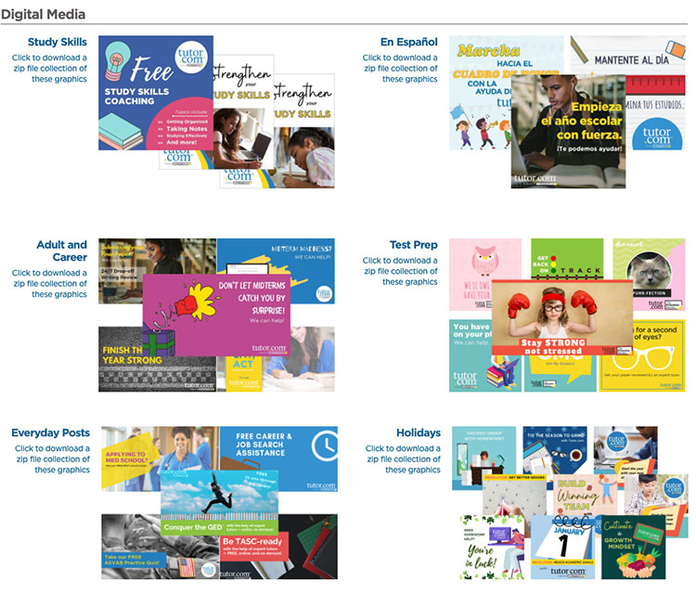

Questions? Comments?
clientsupport@tutor.com

